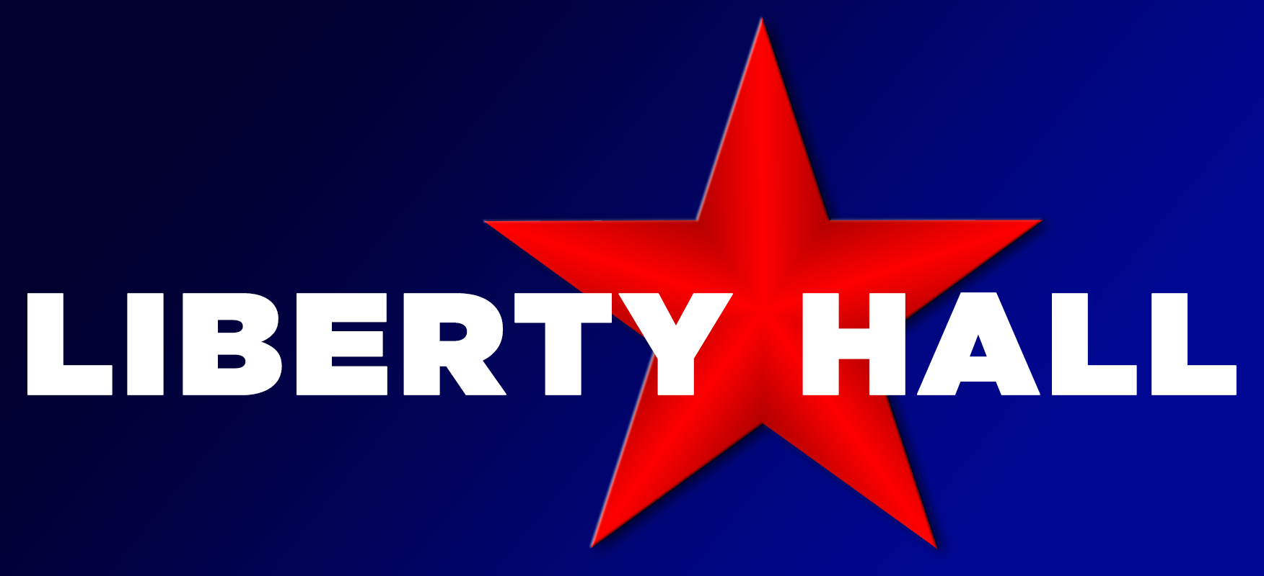
3601 Minnesota Ave.

SATURDAY CITY VENDOR LIABILITY RELEASE FORM:

Name ________________________________________________________________________ Address ______________________________________________________________________
City, State, Zip ______________________________________ Phone # ____________________ Cell # ____________________________ Email _______________________________________
Items planning to sell ____________________________________________________________

Agreement made this_____ day of ______________, 20__, between ___________________________________________________ (name of farmer/vendor) and Saturday City - Arts & Craft Show at Liberty Hall.

I, ___________________________________, (print name) shall indemnify and agree to hold harmless Saturday City and Liberty Hall from and against any and all liability, damage, expense, cause of action, suits, claims, penalties or judgments arising from injury to person(s) sustained by anyone as a result of consuming food acquired from me and/or resulting in any way from the operation of my stall/stand and/or vehicle. I shall, at my own cost and expense, defend any and all suits or actions which may be brought against Saturday City and/or Liberty Hall or in which Saturday City and/or Liberty Hall may be impleaded with others upon any such above-mentioned matters, and, in the event of my failure to do so, Saturday City and/or Liberty Hall may, at my cost and expense, defend any and all such suits or actions and I shall satisfy, pay, and discharge any and all such judgments that may be recovered against Saturday City and/or Liberty Hall in any such suits or actions.

SIGN: ______________________________________________________________________

